Roller Mask Dispenser Cost Analysis

Helena Gill, Avery Hellen, Waleed Khan, and Jayden Ma

Because the audience for the automated roller mask dispenser consists of doctor’s offices and commercial businesses, our team can estimate the total number of possible clients across the U.S. to be around 30 million. We have obtained this number by finding the average number of businesses and practicing doctors in the U.S. It is possible that many of these clients may not buy our mask dispensing machine but it is quite likely for a client to buy multiple mask dispensing machines from us, which is equivalent to several businesses buying one of the dispensers.

We can begin realizing the sales volume of our mask dispenser by first comparing it to similar products which have both automated and manual options, such as hand sanitizer dispensers, paper towel dispensers, and soap dispensers. These products all have extremely broad markets; pretty much anywhere with a bathroom. We can presume that our product is more niche than these comparison products due to the disposable nature and the factor of repeated use for each. For a paper towel dispenser for example, everyone that enters the bathroom would most likely use this product, but for a mask dispenser, it is a little far-fetched to assume that every person entering a grocery store or public space would need a mask provided to them. While this is disappointing to our market analysis, it can help us predict the sales volume of our mask dispenser. Over the first year of sales, we can reasonably assume that all companies selling mask dispensers could make up around 3% of the sales volume of electronic hand sanitizer dispensers within the same period.

To examine our company’s share of this total sales volume, we can estimate that 2 or more companies could sell rival mask dispensers, meaning our business would make up approximately 33% of the market share. This number is justified because we understand our idea is not unique enough to avoid being copied, yet our research has found that no other companies have started marketing electronic mask dispensers on a large scale. This number could also change in years to come, but since we would be one of the first companies marketing this product, we would have an opportunity to make our brand the go-to for mask dispensers, almost like Kleenex in the facial tissue sphere. This translates to our business having a first year sales volume equivalent to 1% of the electronic hand sanitizer dispensing market. In 2020, the hand sanitizer dispensing market made $74.62 million in revenue, translating to a revenue of $746,000 for our company.

One part which will need to be sourced is the housing material, which is made of HDPE sheets. For bulk sales, we found a manufacturer willing to supply 1000 mm × 2000 mm × 6 mm sheets of HDPE for $2.40/kg. Using computer-aided design, we found that one sheet of plastic could make 5 mask dispensers. Using the given density 0.97 g/cm^3, this totals to 11.64 kg of plastic for five mask dispensers. If we were to sell the mask dispenser at $75/unit, dividing the revenue by the sales cost means we would have to produce 10,000 units. This would be a bulk order of 23,280 kg of plastic, totaling to a cost of $55,872. Using the pie chart model for product costs breakdown, we saw that the price of a part is 72% of the total cost with labor forming another 4%. A 4% labor cost would equal around $3104 total if the part cost makes up 72%.

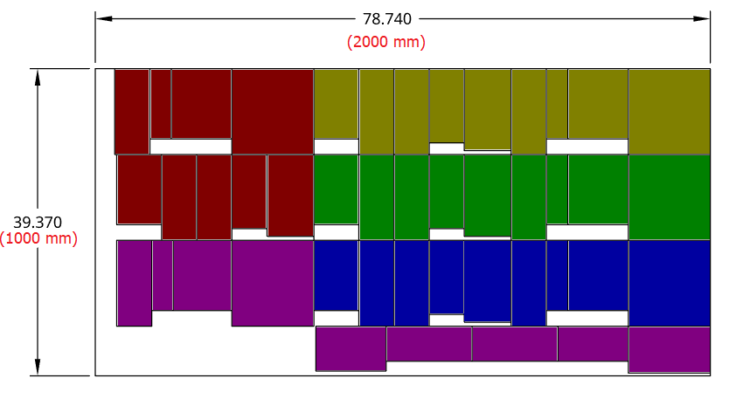

This image shows the layout of the pieces cut from each sheet of plastic. It is color coded to demonstrate how the 5 sets of housing are organized.

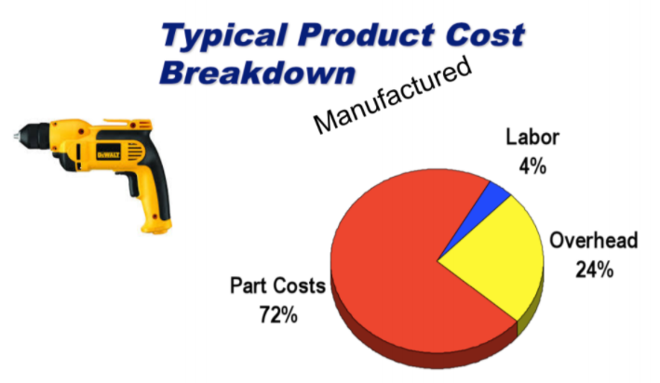

This image provides the relationship between part cost, labor, and overhead which we used to determine the cost per part.

The other part that we will need sourced is the 12-volt DC motor. On an individual basis, motors can be costly such as the current one on our bill of materials which is priced at $14. Generally, as the sales volume of a part goes up, the cheaper it gets. As a result, we found that we can get thousands of motors for $0.67 per part. We were initially divided between this option with another which had a motor with a gearbox and was priced at $1.98. The labor associated with making the gearbox should be cheaper than buying the motor with the gearbox. With these considerations in mind, we decided to stick with the motor sold at $0.67 per part. As mentioned earlier, if we were to sell 10,000 units, it will then cost $6,700 for motors. A 4% labor cost would equal around $372 total if the part cost makes up 72%.

Since we are buying in bulk, the price per part for shipping is greatly decreased as opposed to buying in a small scale. The shipping would have to be done by freight and would add a few thousand dollars to the total cost.

**References**

1. <https://www.alibaba.com/product-detail/Sheet-Hdpe-Sheets-White-Hdpe-Sheet_1931958266.html?spm=a2700.galleryofferlist.normal_offer.d_title.409c30d7nGkfr1&s=p>
2. <https://www.aliexpress.com/item/32991741921.html?src=google&albch=shopping&acnt=494-037-6276&isdl=y&slnk=&plac=&mtctp=&albbt=Google_7_shopping&aff_platform=google&aff_short_key=UneMJZVf&&albagn=888888&albcp=9824643245&albag=103112554314&trgt=896505316494&crea=en32991741921&netw=u&device=c&albpg=896505316494&albpd=en32991741921&gclid=CjwKCAiA-f78BRBbEiwATKRRBFZ9aDnruzoDDVmuivXufgpXpJpAzBkzMQU6n-6wEuOZJjHqxY0TIBoCJDgQAvD_BwE&gclsrc=aw.ds>
3. <https://www.globenewswire.com/news-release/2020/08/17/2079359/0/en/Global-Hand-Sanitizer-Dispensers-Market-to-Reach-181-97Million-by-2027-AMR.html>